The Rittal Foundation sends three fire engines to Ukraine
Helping in times of need: Rittal Foundation donates three fire engines to Ukraine
Haiger, 2025-11-13.
Three fire engines from Dillenburg will soon be deployed in Ukraine. This is being made possible by the Rittal Foundation and the Ukrainehilfe Breitscheid aid organisation. The vehicles scheduled for replacement are urgently needed in Kyiv. That is because every day, fires must be fought and people rescued in a place where rocket attacks are a terrible daily reality faced by the population.
When the 100th aid convoy in the aid organisation’s history rolls towards Kyiv on 6 December, three fire engines will also be part of the fleet. While they have been deployed in and around Dillenburg for the past 25 – 30 years, they will now be helping in the war-torn everyday life of Ukraine: Their deployment after missile attacks can be vital for the survival of both people and infrastructure. “We see images of destruction every day. And that makes every available fire engine all the more important. We have provided help for people in need and at the same time generated income for Dillenburg’s own coffers,” says Rainer Reissner, Managing Director of the Rittal Foundation, which recently bought the vehicles from the town of Dillenburg and has now handed them over to Ukrainehilfe in Breitscheid: “We are happy to provide specific aid and give a sign of encouragement.”

Help for Ukraine as a unifying goal
When the three fire engines were taken out of service, the town of Dillenburg sought the most sensible way to redeploy them. They found the solution in Ukrainehilfe Breitscheid, which has frequently transferred emergency vehicles to Ukraine. The Rittal Foundation covered the €15,000 cost of the vehicles, as well as an additional € 8,500 for transport, representing a significant donation. “Our concern is for the people who are the victims of this war.” “Many thanks to Professor Loh and the Rittal Foundation,” said Dillenburg’s mayor, Michael Lotz, as the vehicle was handed over in Breitscheid.

Those attending the handover were visibly impressed by the presentation by Professor Heinrich Benner, the long-standing chairman and face of Ukrainehilfe Breitscheid, who reported on the association’s voluntary work: it has regularly organised aid transports and other support services for people in Ukraine since its founding in 1992. On the upcoming St. Nicholas Day (December 6), the 100th aid transport since the organisation’s founding will leave for Kyiv. “Since the start of the Russian war of aggression in February 2022, we have sent 151 truckloads of relief supplies, mainly food, hygiene products, medicines and, most recently, building materials. This assistance is urgently needed. And we help wherever we can,” added Professor Benner, who not only thanked the Rittal Foundation and the town of Dillenburg for their support, but also made it clear once again: People in need always depend on the help of others.

The Rittal Foundation, the Friedhelm Loh Group’s charitable foundation, also acts in this spirit: For decades, working together has been a matter close to the heart of this family business. To mark Rittal’s 50th anniversary in 2011, owner Professor Friedhelm Loh established the Rittal Foundation, which officially began its funding activities in 2012. Since then, the Rittal Foundation and the Friedhelm Loh Group, as well as their employees and management, have donated over €10 million to charitable causes, mostly near the company’s locations.

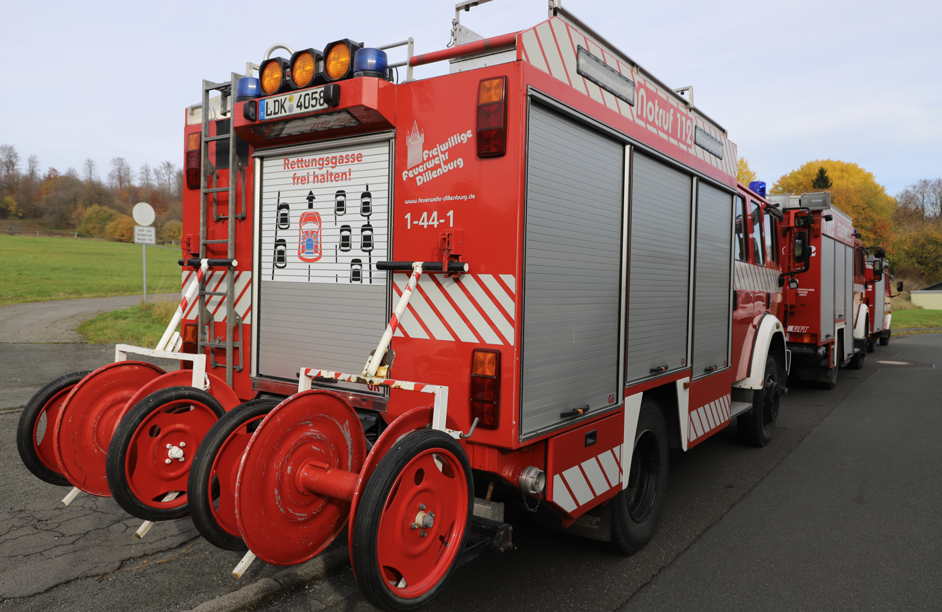 |  | 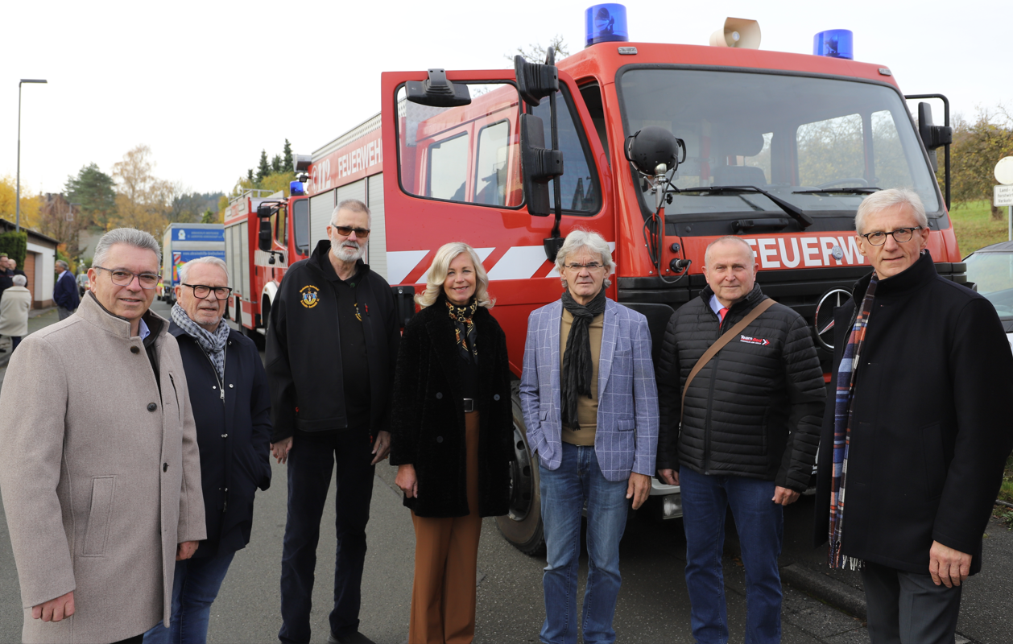
Image 1  Three fire engines from Dillenburg are being given a second life and will soon be put into use in Ukraine. The Rittal Foundation and the aid organisation Ukrainehilfe Breitscheid are making this possible. |  | Image 2  Joint aid for Ukraine, from left to right: Michael Lotz, Mayor of Dillenburg; Hans-Werner Schech, First City Councillor of Dillenburg; Professor Heinrich Benner, Chairperson of Ukrainehilfe Breitscheid; Cornelia Hepp and Matthias Betz, Rittal Foundation; Sergej Lakhno, Managing Director of Rittal Ukraine; and Rainer Reissner, Rittal Foundation

May be reproduced free of charge. Please name Rittal Foundation as the source

Rittal Foundation

The not-for-profit Rittal Foundation was established in 2011 by Friedhelm Loh, Owner and CEO of Rittal, to mark the company’s 50th anniversary and, following two increases in 2018 and 2021, has a foundation capital of 40 million euros. The income from the foundation’s capital is distributed annually and is used for charitable projects focussing mainly but not exclusively near individual Friedhelm Loh Group locations.
For more information, visit www.friedhelm-loh-group.com.

Corporate Communications Rittal Foundation
Dr. Carola Hilbrand Friedhelm Loh Group
Corporate & Brand Communications Rudolf-Loh-Straße 1
Phone: 02772/505-2527 35708 Haiger
hilbrand.c@rittal.de www.rittal-foundation.de

